Home Page

Hero Section

4-Color System™
A Visual Framework for Reading Market Behavior
Understand liquidity shifts, execution context, and structural pressure
through a simplified 4-Color price model.

LITE — OFFICIAL ELEMENTS
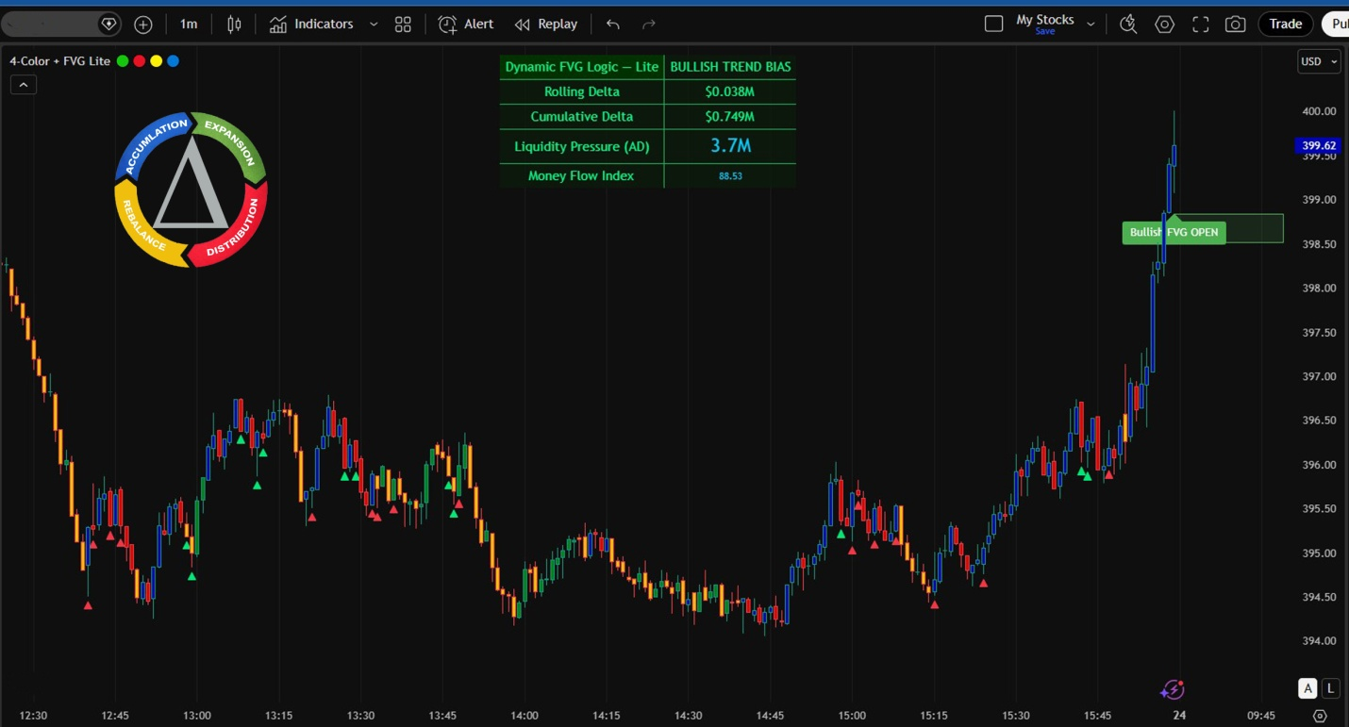

Powered by 4Color Liquidity States
The 4-Color System™ turns complex price behavior into a readable structure.
Available to all TradingView users.

Lite Version – Free Access
https://www.tradingview.com/script/dWscMbbP-Four-Color-Order-Flow-System/
Join Pro Waitlist
Apply for Elite

Built for traders who care about context, control, and survival — not alerts.
Purpose: Learn to read control before imbalance.
The Power of 4-Color System
Price shows where.
4-Color shows who.
INTRO – Lite Version
Dynamic FVG Logic – Lite (4-Color Based) is a price behavior reading system, not a direction-guessing indicator.
It reads who is in control through candle color behavior.
It helps you:
See quickly who’s driving the market
Know whether price is real movement or a trap
Avoid trading when control is unclear
No BUY / SELL
No entry signals
Observation only – real-time market state
4-COLOR CANDLES – How to Read Them
 RED – Active Selling Pressure
Sellers are in control
Price moves fast and decisively
Often appears after breakdowns, distribution, or traps
 Multiple Reds = don’t bottom-fish
 GREEN – Active Buying Pressure
Buyers are stepping in for real
Price is being pushed, not dragged
Used to judge whether an up-move has real force
 Green without follow-through = likely technical bounce
 BLUE – Swing High / Resistance Zone
Price is entering a previously controlled area
Common behaviors:
Slowing down
Rejection
Short accumulation
 Not a buy zone — observation zone
 YELLOW – Swing Low / Liquidity
Liquidity sweep area
False breaks are common
Often the start of a reaction
 Not a safe bottom — force-testing zone

Join Pro Waitlist link to Pro page
Apply for Elite, link to Elite page

System Page — “How it works”
Chart Narrative (Timeline Story)

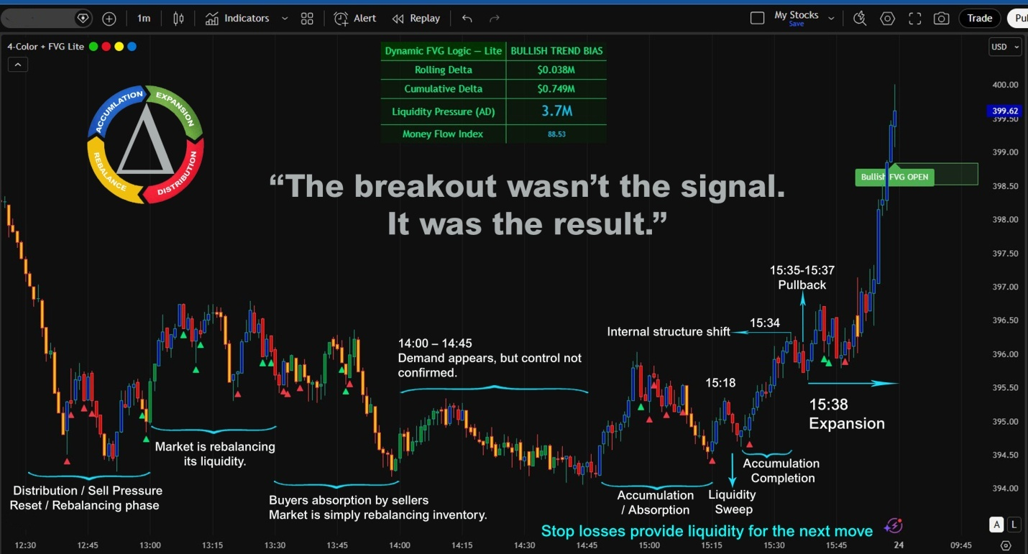

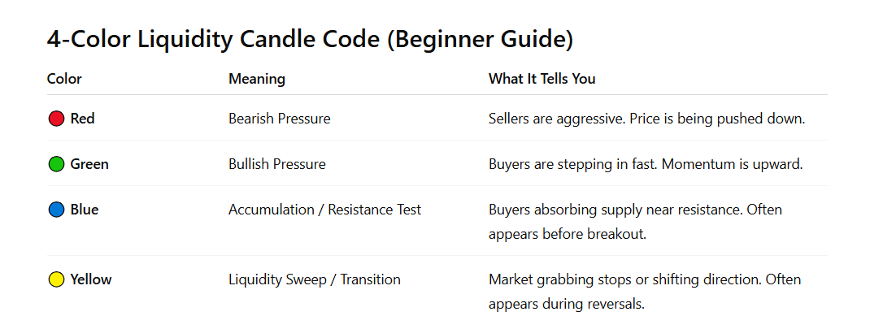

Simple rule for beginners
-  Many Reds → Sellers control market
-  Many Greens → Buyers control market
-  Repeated Blues → Accumulation building
-  Yellow spikes → Liquidity events

How the Colors Tell the Market Story

12:30 – 13:00

Candle behavior:
 dominant

Meaning:

Sellers are unloading positions.
Price forms Lower High → Lower Low.

Market bias = Bearish

13:00 – 13:30

Candle behavior:
 +  mixed with  and 

Meaning:

Market is cooling down after the sell-off.

This phase is inventory balancing, not accumulation yet.

13:30 – 14:00

Buyers absorption by sellers

Market is simply rebalancing inventory

14:00 – 14:47

Demand appears, but control not confirmed

14:48 – 15:14

Accumulation / Absorption Zone

 Blue — Absorption

Blue candles appear when:
- Buyers absorb selling pressure
- Price holds near resistance/support
- Market refuses to move lower

Meaning:

➡ Smart money quietly building positions

This is the core signal of accumulation.

 Red — Sell Attempts

Red candles here represent:
- Sellers still trying to push price down
- Weak bearish pressure

But the key detail:

Price does not continue dropping.

Meaning:

➡ Sellers are being absorbed by buyers.

That is exactly what absorption looks like.

 Yellow — Liquidity Probes

Yellow candles often appear when:
- Market tests liquidity
- Small stop hunts occur
- Market transitions between pushes

Meaning:

➡ Market is searching for liquidity inside the range.

This is common during accumulation because institutions need orders to fill their positions.

Tips: If you see:

 Blue appearing repeatedly
 Red attempts failing
 Yellow liquidity probes

and price stays sideways

➡ That is classic accumulation behavior.

What Dynamic FVG Logic-Dashboard Revealed

Around this zone noted:

• Rolling Delta rising
• Cumulative Delta rising
• Liquidity Pressure (AD) increasing

This is the key clue.

Even though price looks slow, the order flow shows buyers building positions.

This is exactly what accumulation looks like.

Why Price Does Not Move Yet

During accumulation:

Smart money does not want price to run yet.

They need time to:

• collect liquidity
• fill large positions
• absorb selling pressure

So price stays sideways on purpose.

15:18 -15:21

Candle behavior:
 spike with long wick

Meaning:

Market briefly pushes lower to trigger stop-loss orders.

Liquidity gets collected.

This fuel is needed for the next move.

15:22 - 15:34

Candle behavior:
 followed by 

Meaning:

Buyers begin to break internal structure.

Momentum starts shifting upward.

15:35 – 15:37

Candle behavior:
Small  pullback
then  support

Meaning:

Market tests if buyers can hold the price.

Higher Low forms.

Buyers maintain control.

15:38

Candle behavior:
 strong sequence

Meaning:

Momentum accelerates.

The market enters expansion mode.

15:41

Candle behavior:
Strong  impulse

A Bullish Fair Value Gap (FVG) appears.

Now breakout traders finally notice the move.

But the move was already prepared during: 15:22

The Lesson:

Price moves last.

Liquidity moves first.

Most traders only react to the breakout candle.

The 4-Color Liquidity System shows the behaviour building before the breakout happens.

Disclaimer:
Trading involves substantial risk of loss and is not suitable for all investors. The content, tools, and signals provided on this website are for educational and informational purposes only and do not constitute financial advice, recommendations, or a solicitation to buy or sell any financial instruments. Past performance is not indicative of future results. Users are responsible for their own trading decisions.

